HAD PROJECT

Project Name:-CompareX

Members:-

40005 Divyesh Wagela

4082 Armaan shaikh

4063 Daniel Injeti

4023 Abhay Jha

4059 Nitin Singh

Project Description:-

A price comparison application to compare prices of different electronic products from popular websites and to display it in our application and to display the prices in our application.

The price comparison App has shot into popularity soon after the eCommerce revolution. The value proposition provided by the price monitoring sites helps consumers save a considerable amount of money while shopping online. The ability to check the price of a product on numerous e-commerce portals at one place brings convenience and saves time. It offers a lucrative business opportunity by drawing significant revenue from affiliate sales and advertising. Starting an online price comparison app is not a cakewalk and requires technical expertise and a reliable means of price data acquisition.

Screen Designs:-

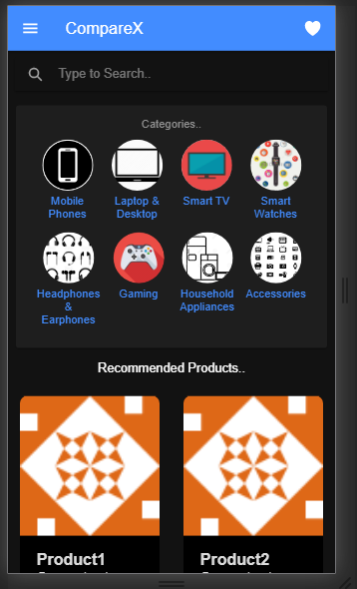Home Screen

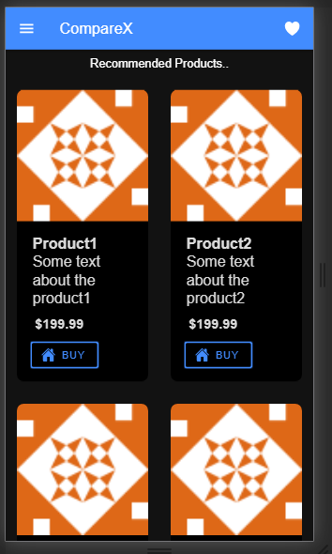

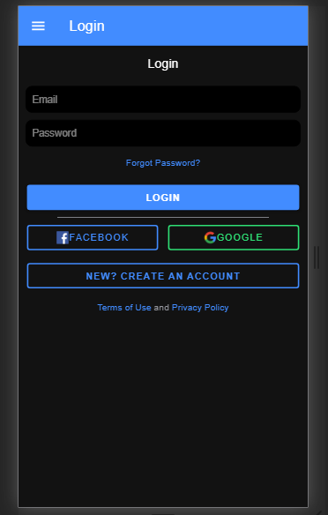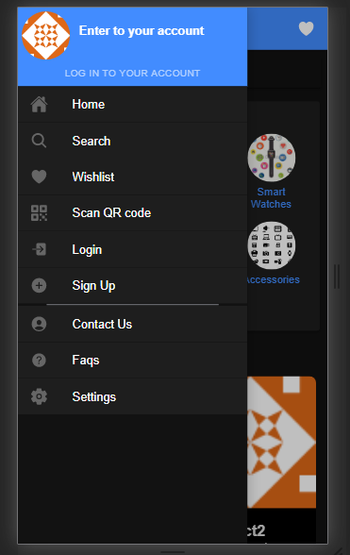Side Menu:- Login Page:-

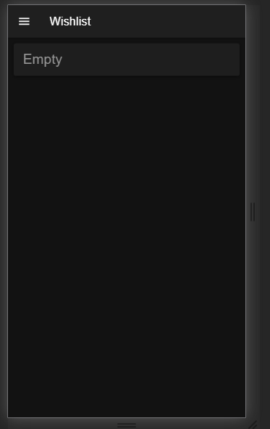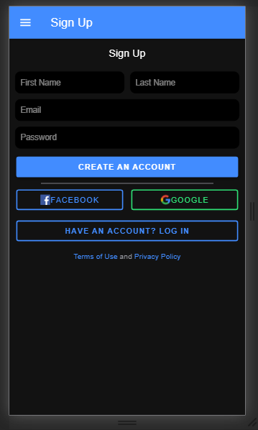Sign up Page:- Wish list:-

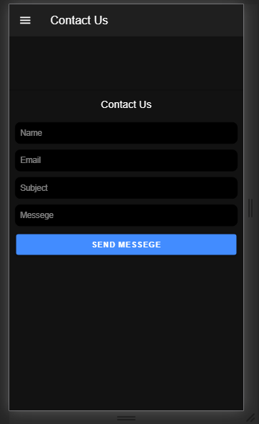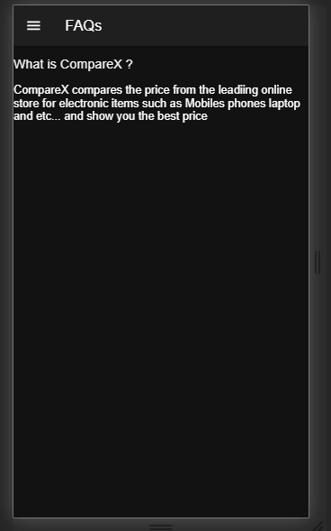FAQs:- Contact Us:-

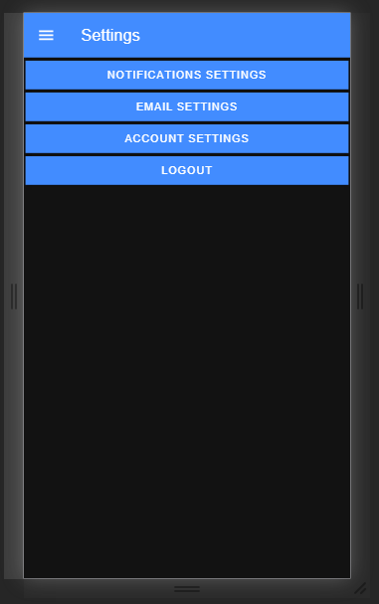 Settings:-